2014 Annual
Inmate Population Statistics

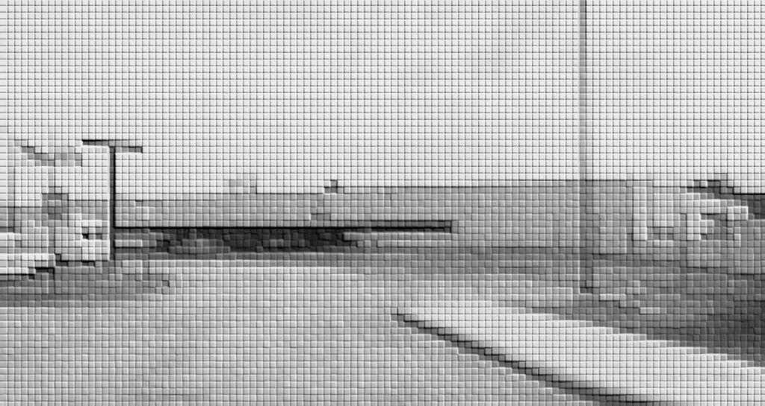

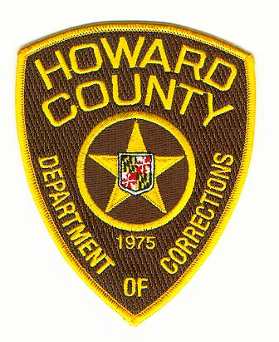
Howard County Detention Center
7301 Waterloo Road
Jessup, Maryland 20794

Jack Kavanagh, Director

Mission Statement

The mission of the Howard County Department of Corrections is to protect the citizens of Howard County by providing a secure facility for persons legally confined in the County. The Department provides for the safety of the inmates and staff by maintaining a humane, clean and orderly living and working environment. It is also the policy of this Department that no inmate is discriminated against with regard to programs, services, or activities on the basis of race, religion, national origin, sex, disability or political beliefs.

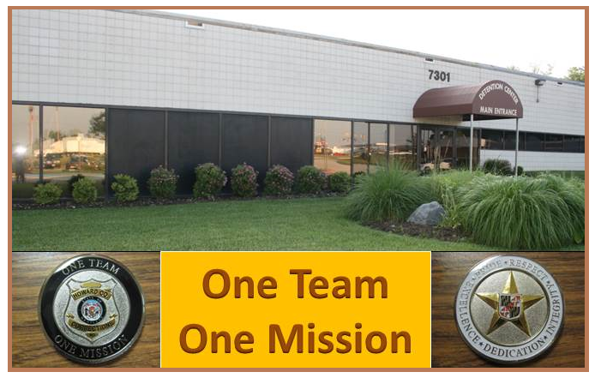

02132015.0830

